Trends In Home Interior (2019)

As somehow we really want a change in our life as on time to time. We want to upgrade to a level from an old one that is also seen in our things that we purchase from a market and somehow this is a current trend in the market towards a change in the style or overall look of our home.

Yes, we are rightly said about current trends in the interior design of the home. As every year we as a human want to change the look and feel of our home. So we just see what is the trend going in the market. By looking at we just change the look of our home.

So there are generally current top 10 trends that are available in the market towards an interior design of our home that is mention below.

**1. Natural Elements**

As we have seen due to the advanced technology which will be seen in the modern era, but apart from that it is really much important to have a natural element to be added rather than those tech-obsessed things in the home.

As through add natural elements, it gets you to provide a feel through natural things and what it can give to your health. So this is really one of the latest trends in the design of a home.

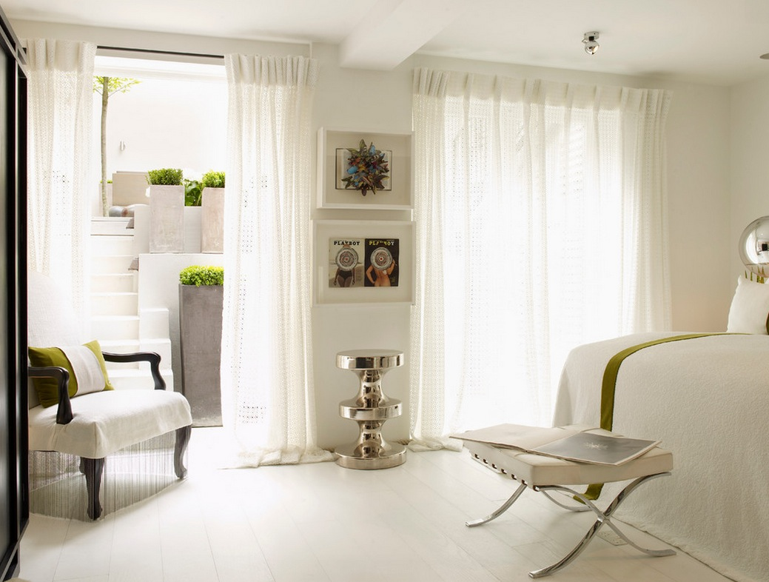

**2. Velvet Furnishings**

As this is also really one of the upcoming trends in the field of the interior design of the home as this technique is seen in the old days. But now this can be viewed as a luxurious and most comfortable thing in the design.

As it provides a good look to your home and with that, it generally attracts the minds of people as this provides the multi-dimensional fabric functionality to your home.

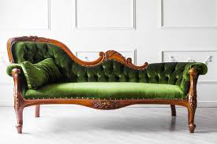

**3. Floral Patterns**

This is also one of the latest trends that we see in the market and it adds to provide a new look to your old home. As this is not a new technology as this is started from the old days. But now due to a change in technology it also would have the latest feature to be there.

As these floral patterns nowadays would be very much different from those used in olden days as these techniques would really be refreshed and modernize your home.

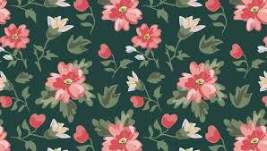

**4. Black and White Decor**

This is also one of the latest trends going on in the market and people are really attracted towards this feature and they really want to add this feature or look to there home so it provides a new beauty to there house.

It is also admirable that the combination of black and white adds beauty to the home. As both these colour are a symbol of balance and boldness in your home. So that's the main reason why people really attract towards this trend.

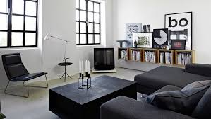

**5. Millennial Pink**

As this feature also takes a lot of adds on from the previous year and those adds make these as current market trends in terms of the design of a home. This pink colour would add to the beauty of home decor and provide a luxurious environment to it.

Due to this creative look that it possesses would attract in the minds of people and they are going away towards this fashion.

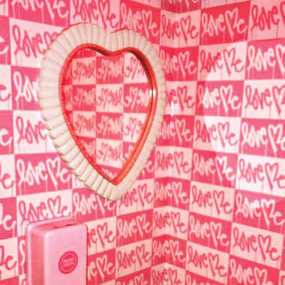

**6. Vintage Lighting**

Vintage Lighting is one of the old technique but somehow due to adds on a feature to this attraction to people and they are really moving towards this trend.

This lighting also has it's a natural beauty and with that, some vintage pendants are also using with it.

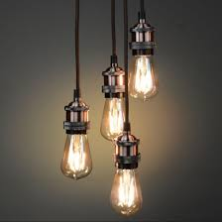

**7. Bucket Sinks**

This is also one of the latest trends that are going towards an interior design of the home as it also comes under the category of vintage design but no matter it also attracts in the minds of people.

It generally used in kitchens and bathrooms and somehow recently they are using in hotels, farmhouse but they would definitely be seen in the houses also.

This bucket sink is also known as trough sink and these sinks would be family friendly.

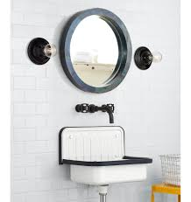

**8. 70'S Chic**

As this is one of the old design trends but would grow fastly in the recent world and it provides you with a funky texture. This 70'S chic is all warm palettes.

These generally provide a more look especially in the living room and bedroom design as it provides an amazing personality to your home.

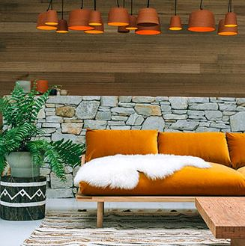

**9. Canopy Beds**

Though these canopy beds are not seen since the 1980s but generally the updating they have made in these would make them now as current market trends in terms of the interior design of a home.

Generally, in olden days they take a huge amount of space so somehow it would be very much difficult to settle in small rooms of houses. But nowadays due to adds on functionality made their size small and now they can be settled in small areas.

As these canopy beds provide a good and a comfortable body posture so that it wouldn't effect on your body.

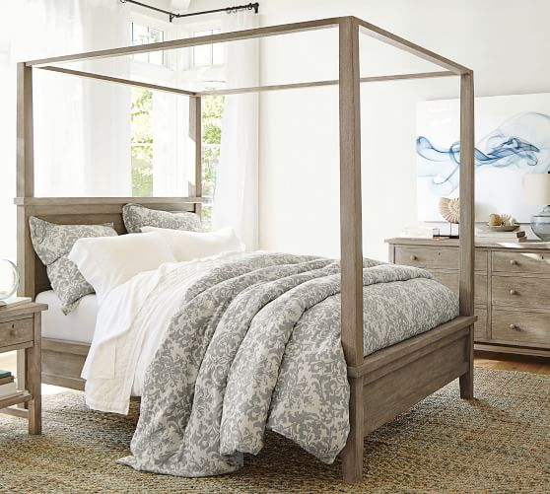

**10. Agate Wallpaper**

As this is one of the modern trends that are available in the market that's agate wallpaper. Generally, we don't see the wallpaper in the houses, but in the year 2018, this trend comes into the market and really made a powerful impact on the minds of people.

In the year 2019, this is one of the fast-growing trends as everyone wants to add this feature in their house. As it provides a natural and a bold look to your home.

So that's all from my side I think you would definitely like this information and if yes so don't forget to share this information with your friends and family members.

